St Augustine’s Primary School Healthy Packed Lunch Guidance

We encourage parents to provide healthy well balanced packed lunches.
For children aged 5 years and above preparing a healthy well balanced child’s lunchbox, includes:
- Starchy foods – these are bread, rice, potatoes, pasta etc
- Protein foods – including meat, fish, eggs, beans etc
- A dairy item – this could be cheese or a yoghurt
- Vegetables or salad
- A portion of fruit
- A healthy drink such as water or milk
INCLUDE:
- Minimum of 1 portion of fruit and 1 portion of vegetables everyday
- Meat, poultry, fish and non-dairy protein e.g. pulses
- Oily fish at least once every few weeks (e.g. sardines, salmon)
- Starchy food such as bread, pasta, rice, potatoes including wholegrain varieties
- A dairy product milk, cheese and yoghurt (unsweetened, low/medium sugar) and low/medium fat for children aged 5+, any dairy alternatives should be unsweetened and fortified
- Water or milk (semi-skimmed or skimmed).

LIMIT:
- Processed meat products sausage rolls, pies, sausages etc
- Cakes and biscuits to be enjoyed as part of a meal occasionally not as a snack
- Fruit juice: no more than 150mls per day (restricted to children aged 5+)

DO NOT INCLUDE:
- Salty snacks such as crisps, nuts etc
- Sweets and chocolate
- Sugary soft drinks

For more information and practical tips for children aged 5 years and above: https://www.nhs.uk/healthier-families/recipes/healthier-lunchboxes/
For our children, aged 1-4 years old, preparing a healthy packed lunch includes:

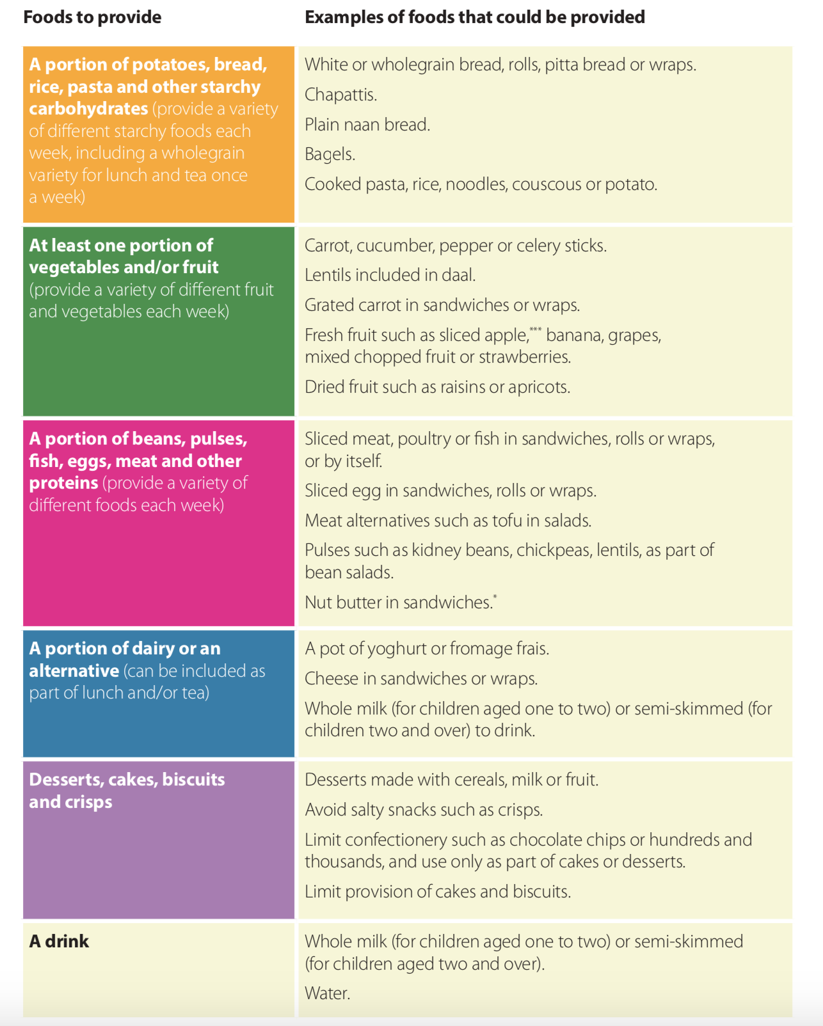

For more information and practical tips for children aged 1-4 years old:
https://static1.squarespace.com/static/59f75004f09ca48694070f3b/t/5a926d288165f549b5a68ca2/1519545646246/Packed_lunches_Dec17.pdf

